Blazer Marine
Cowl Installation

We have put together this separate manual to show you how to install your cowl onto your boat. You may do this procedure before or after sheeting the top of your boat. If you do it before just use scrap pieces of 1/16 inch ply to simulate the top where needed. Follow these steps and you will be assured of having a nice fitting cowl to compliment your new boat. Thank You, Blazer Marine.

Step#1: Getting ready to fit the cowl to the boat. We will fit it to the engine after we do this first. Mark the centers of both the cowl and the boat. Use blue tape on the boat.
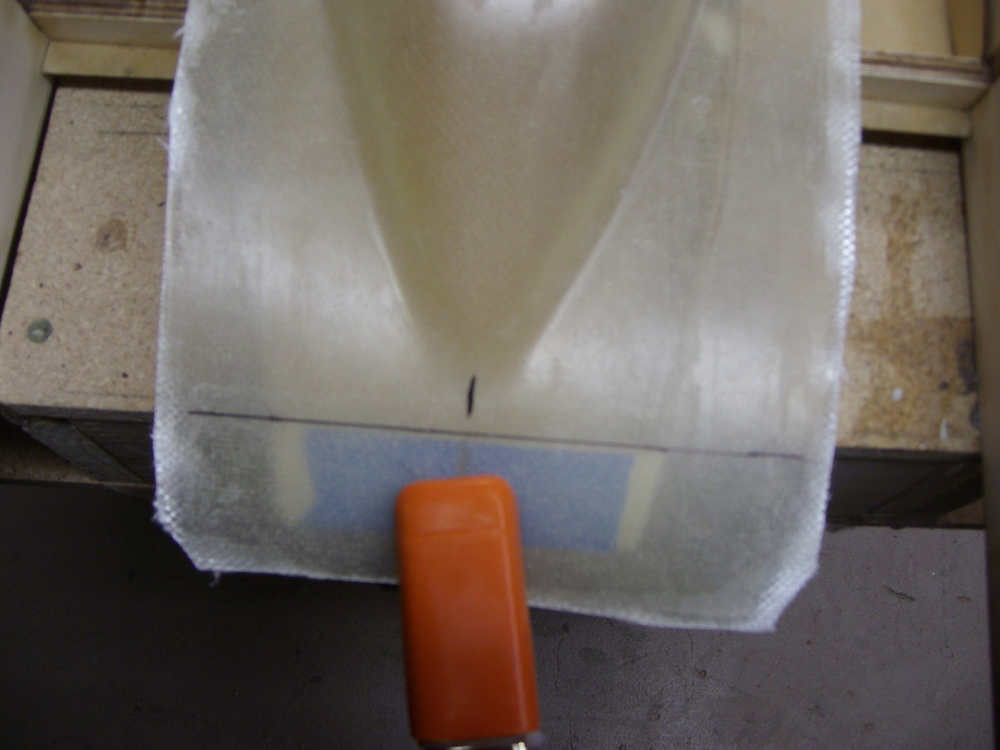
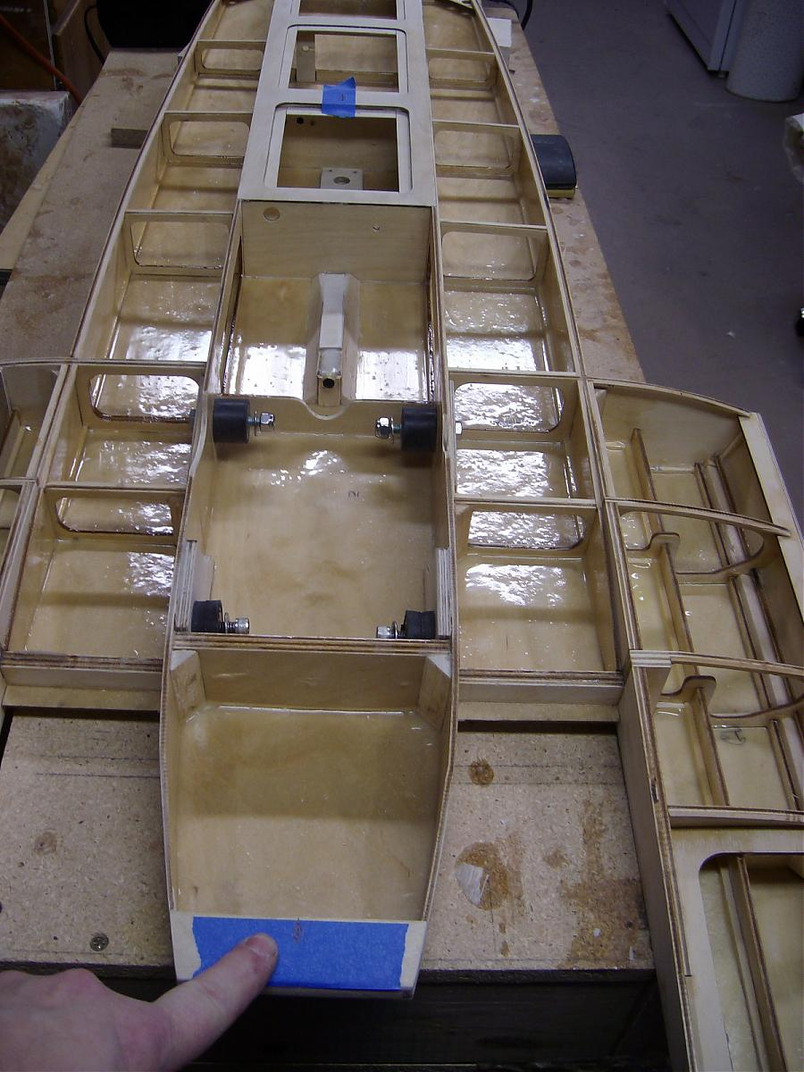

Step#2: Place cowl on the boat and line up the marks you made. The cowl is plenty transparent for this. Mark the ends of the nose piece to give you a reference line to make the front cut.
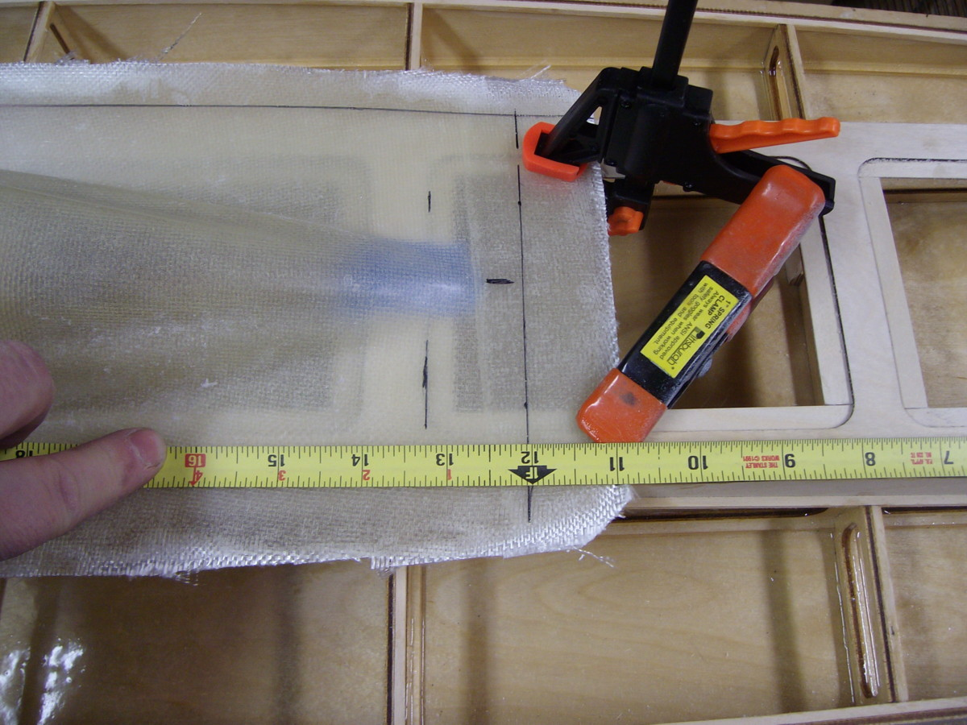
Step#3: Mark the rear as well. Also measure from transom to cowl on both sides and draw a line across to give you a straight cut line. You may shape the rear of the cowl to whatever desired shape you like. It does not have to be square here.

Step#4: Now with the cowl clamped to the boat trace the shape of the boat onto the cowl.
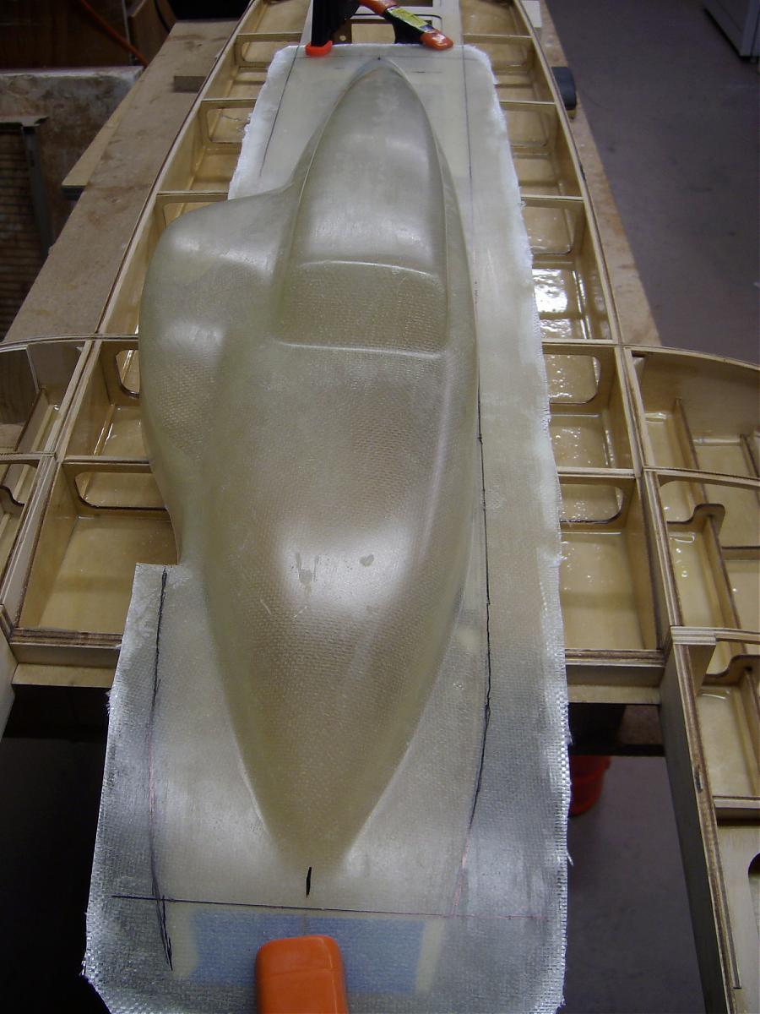
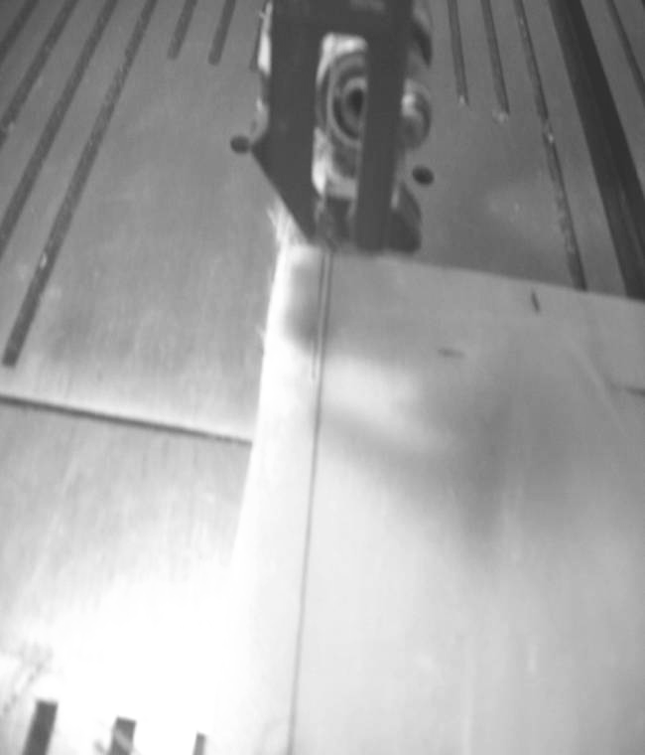
Step#5: Now use a bandsaw or your preferred method to cut just outside this line. Final sanding is fast with a rougher grit sandpaper to finish it to shape. Lay cowl onto the boat. It should be very close to the shape of the boat. Remember you can fine tune it later.
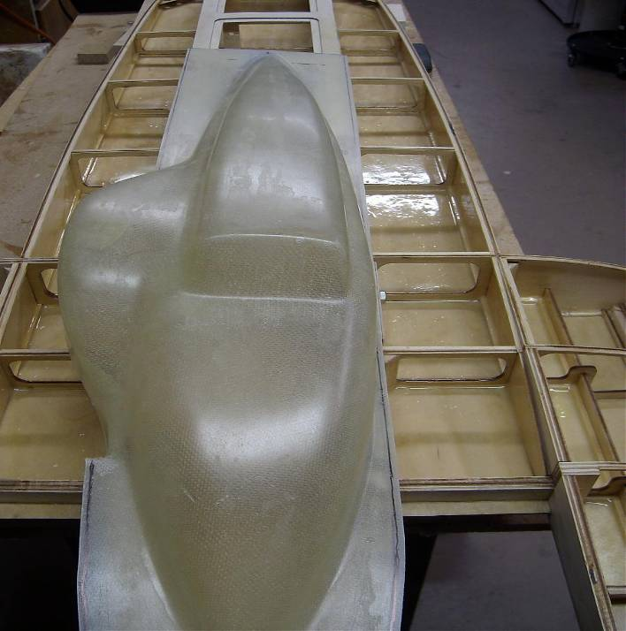

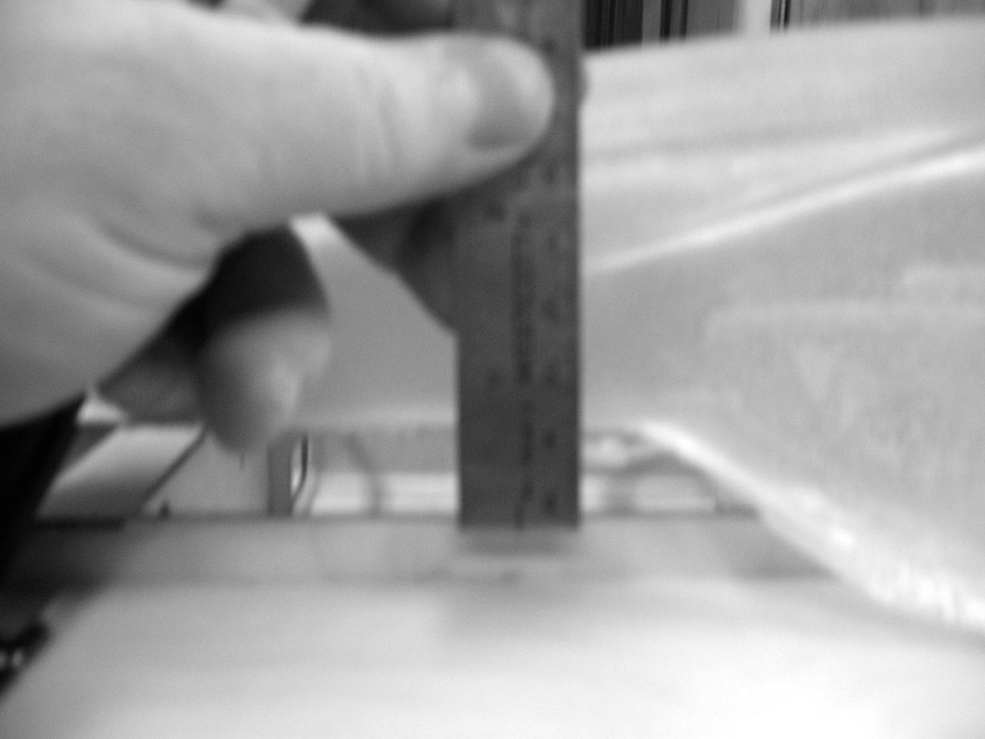
STEP#6: The part of the cowl that rests on the top sheeting where the carburetor is needs to be trimmed. Measure the distance you need to take off from this part to make the cowl sit down on boat. Look at the back of the cowl and you can see the amount you need to take off. Do this in several steps as you'll see until you get it to fit.
Our first measurement in this photo was just over 1/2 inch. Yours may be something different that’s ok all cowls might be a hair different. Now take a piece of scrap 1/2" block or something close to the measurement you got and rest a pen on top. Trace a line onto the cowl sliding this block which is resting on a temporary piece of 1/16" inch ply to simulate top skin.

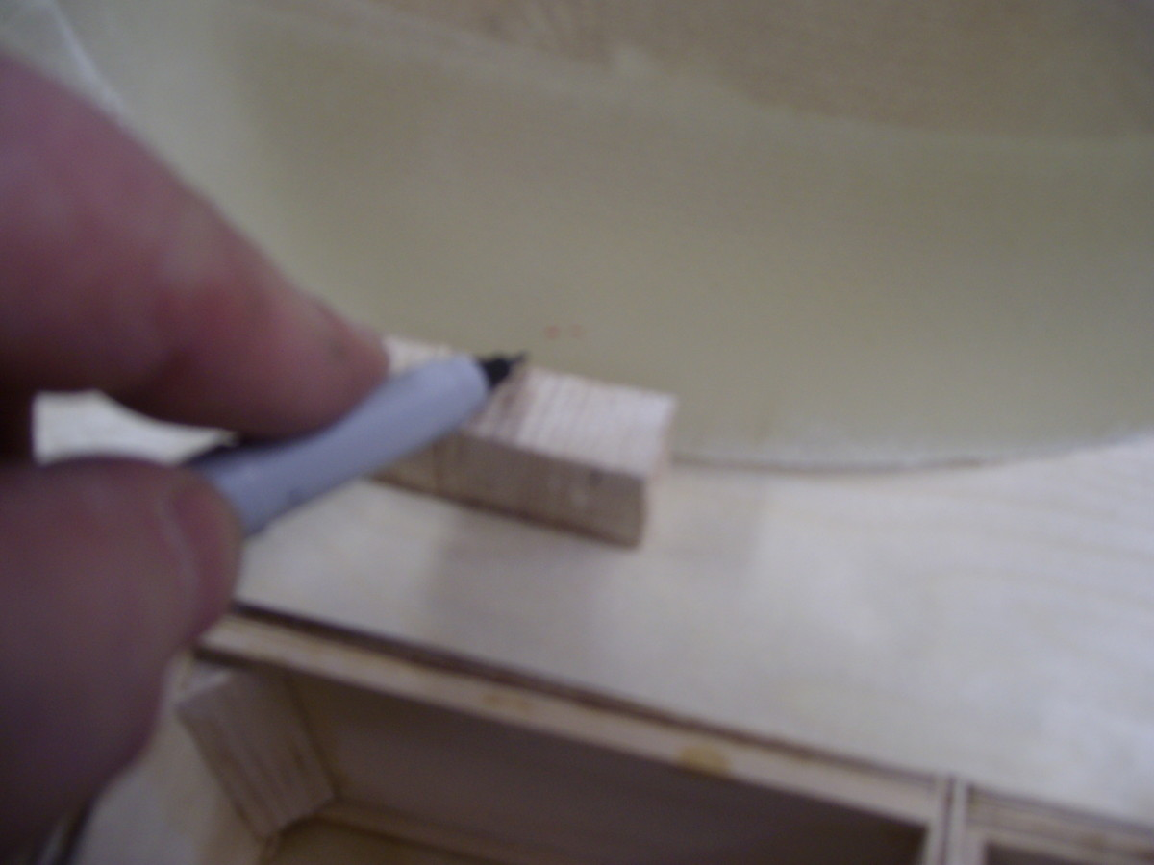
The block follows the shape of the boat giving you the correct shape to take off.
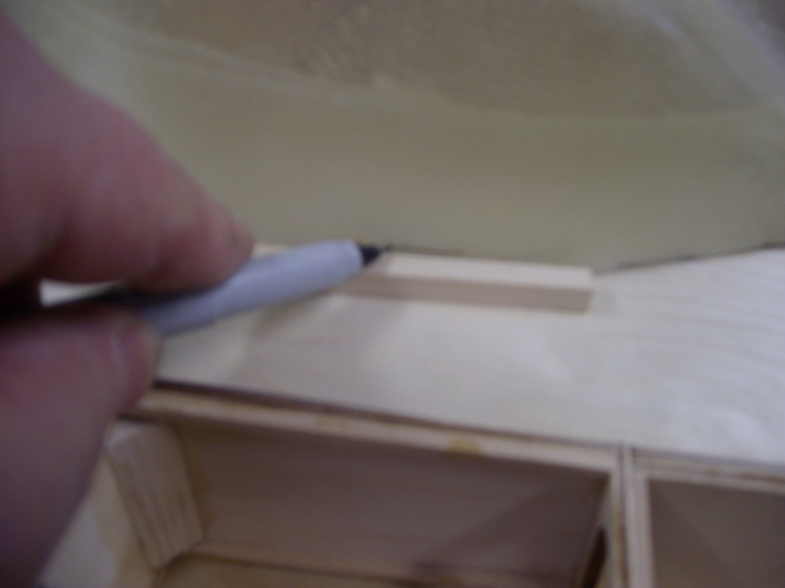
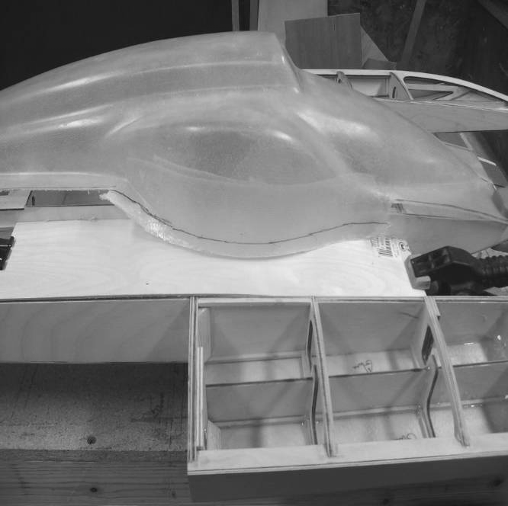
This picture shows the line you need to cut. You now can see how this method is working! Continue this process using thinner blocks as you get closer. Fine tune with a sanding block to finish!!

Here you can see how nice your cowl fits. The rear of this one has a taper look to it.
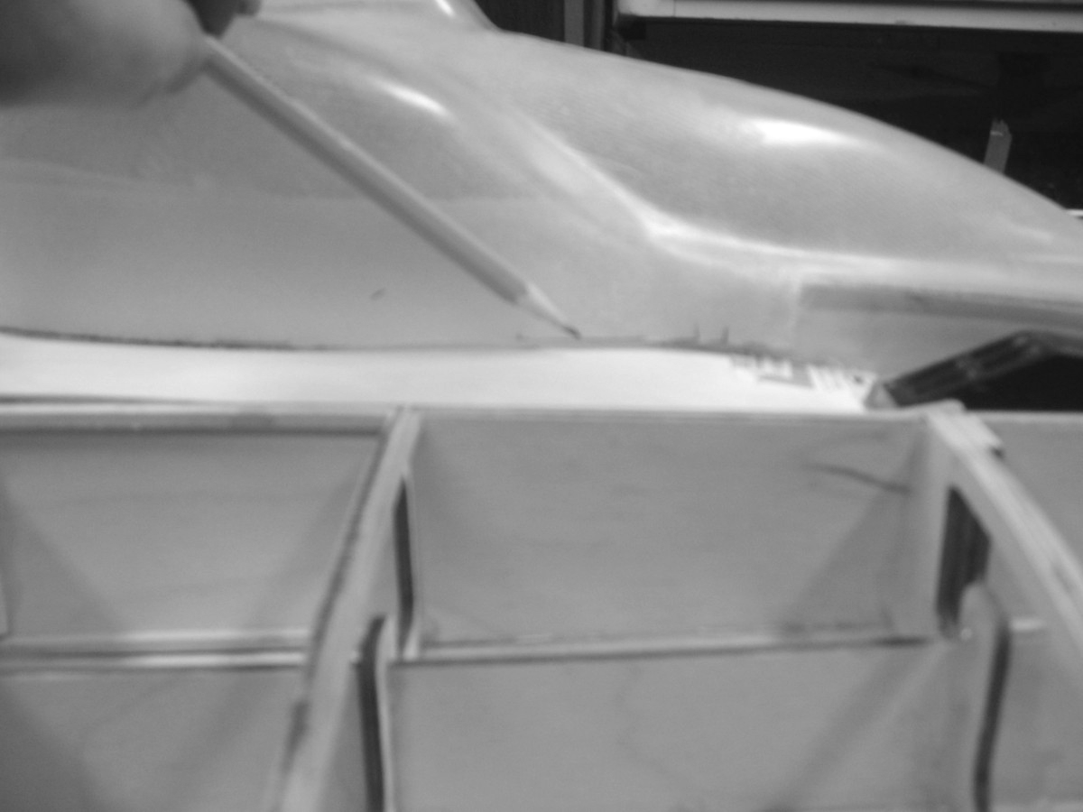
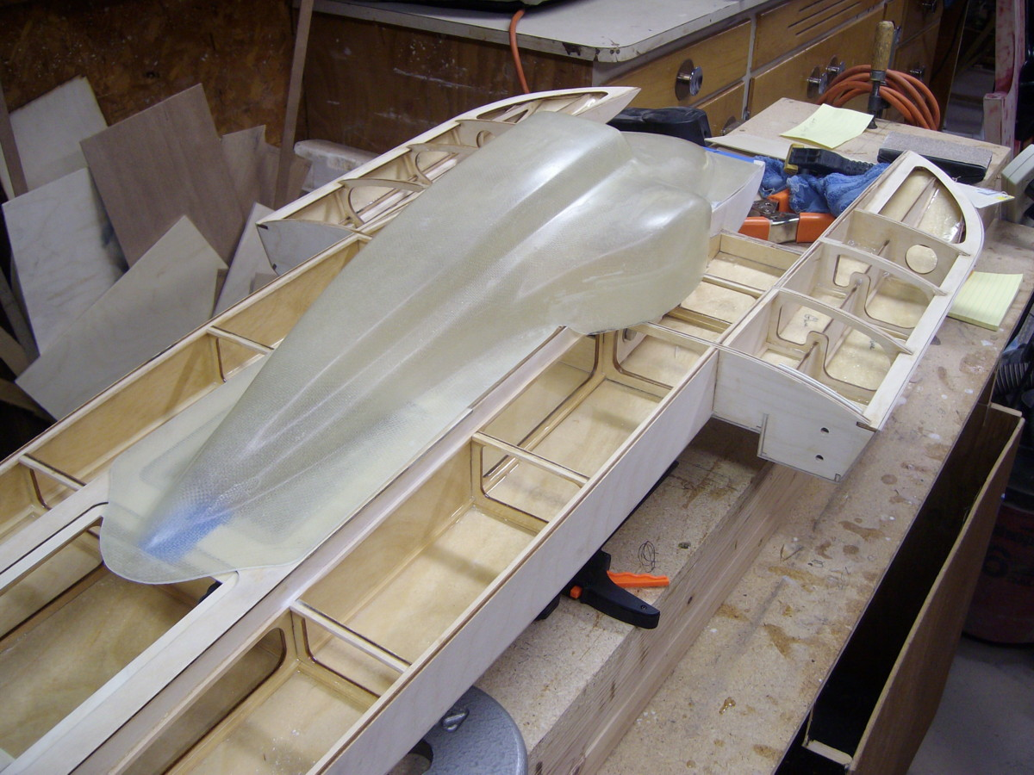

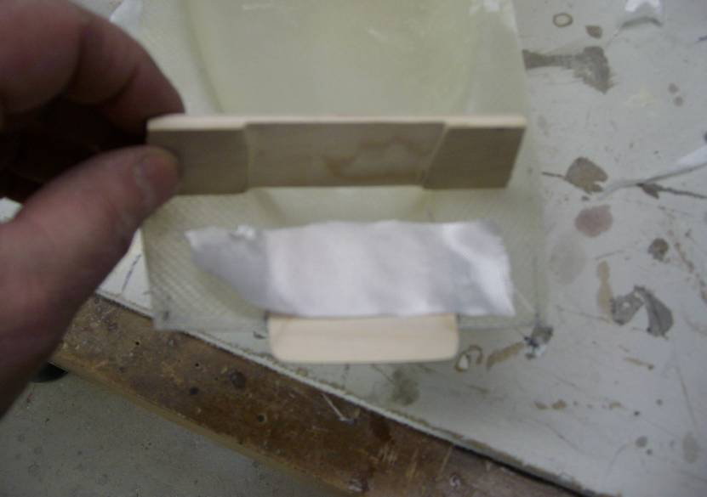
Step#7: Installing the tab in the front now. There are three pieces, a tab, a piece of fiberglass and a piece that sandwiches them together. Clean the cowl with some rubbing alcohol prior to gluing. Use fiberglass and resin for this step.

Step#8: Now we have fit the cowl to the boat let’s fit it to the engine next! Use the following explanations and pictures to guide you through this process.

To mark the spark plug on cowl, insert a piece of scrap 1/4 square hardwood into sparkplug hole. This is cut so it just fits under top of cowl.
Put on the cowl and mark the plugs location.
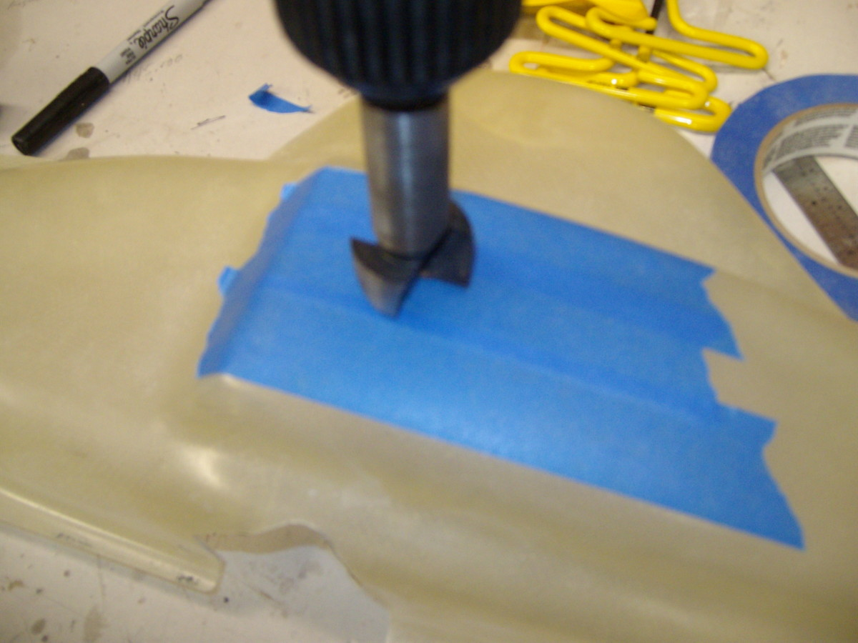
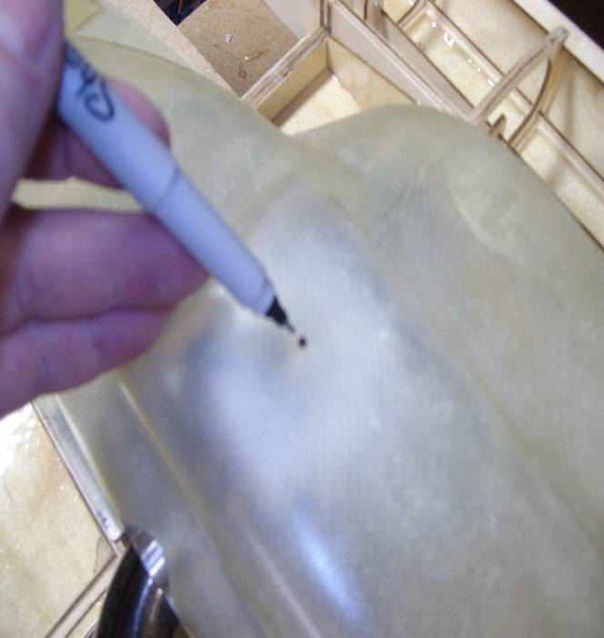
Drill this hole with a forstner bit with blue tape helping with chip out.

Now drill a smaller hole in front of this, then finished with your dremel sanding drum to make the final desired shape. Mark the pipe hole with the pipe off and cutout excess and finish it off with your dremel!
And here’s the finished product!!!

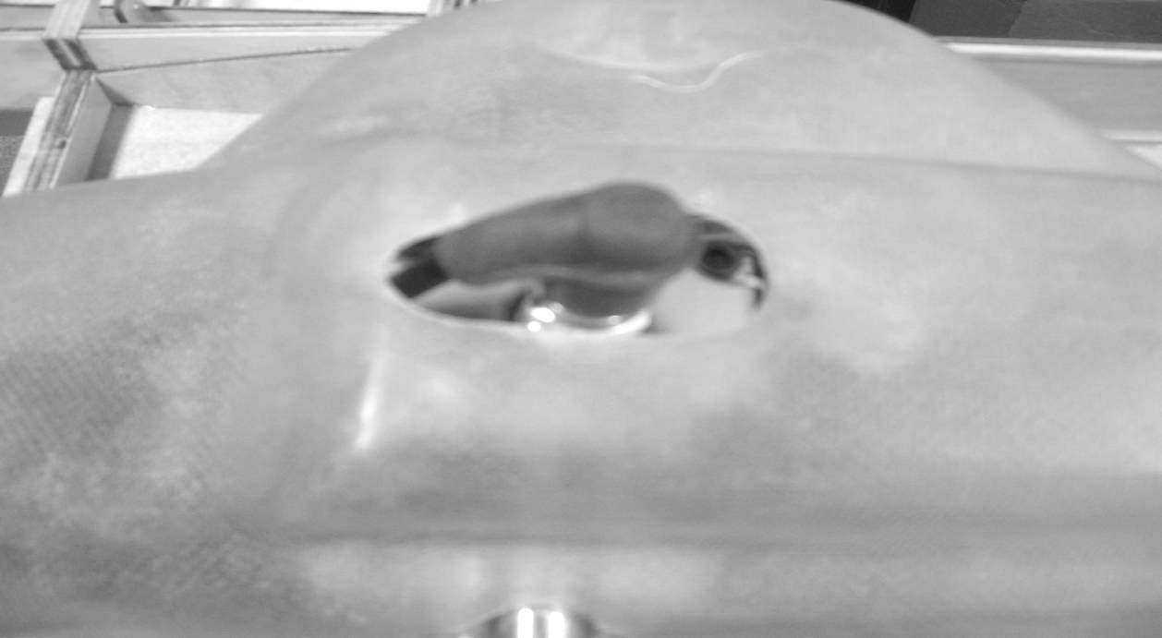

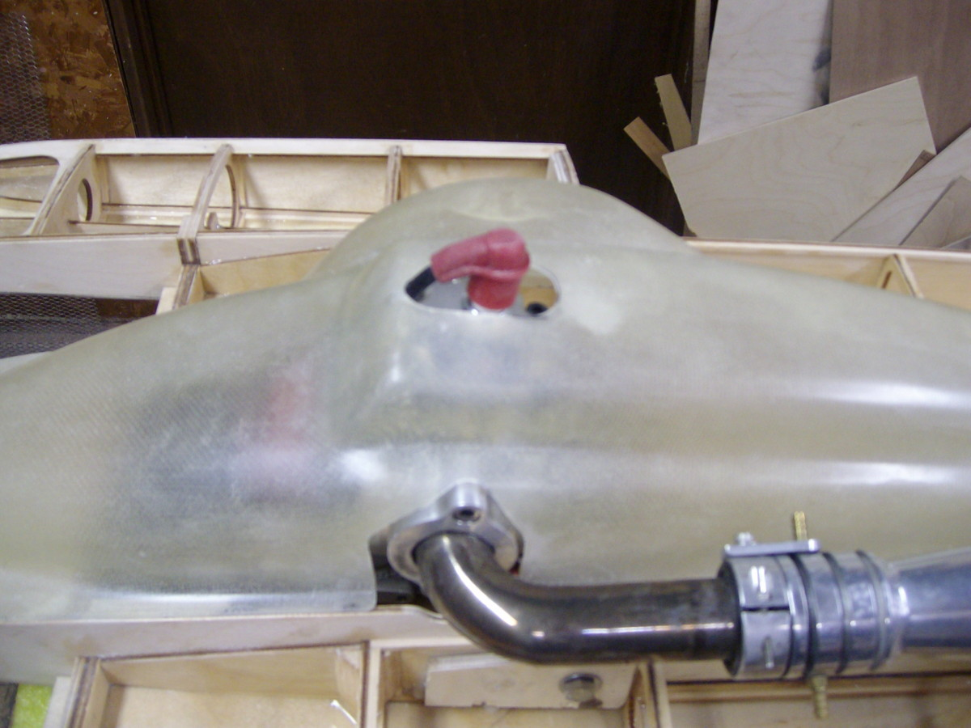

Step#9: Now your cowl looks great. We need to put a water deflector on the boat for the carburetor. The top sheeting must be on the boat to do this next step. Place the cowl on the boat and trace around the portion of it that covers the carb. Take the cowl off and you can see the outline of the deflector shape. Remember now we drew this line on the outside of the cowl so your deflector will sit in from this line or else your cowl won’t go on at all! Giving your self ample room for finishing material thickness use some 1/8 inch ply and form the shape of the deflector. Epoxy this in place. On the inside of your deflector it’s a good idea to reinforce this area using some light weight fiberglass and resin. Test fit your cowl and then add another small deflector in the front on the outside of the cowl as shown. Leave room for the finishing materials.

